SIMPLE LINEAR REGRESSION

Simple Linear Regression is a type of Regression algorithm that models the relationship between a dependent variable and a single independent variable. The relationship shown by a Simple Linear Regression model is linear or a sloped straight line, hence it is called Simple Linear Regression.

The key point in Simple Linear Regression is that the dependent variable must be a continuous/real value. However, the independent variable can be measured on continuous or categorical values.

Simple Linear regression algorithm has mainly two objectives:

1. Model the relationship between the two variables. Such as the relationship between Income and expenditure, experience and Salary, etc.
2. Forecasting new observations. Such as Weather forecasting according to temperature, Revenue of a company according to the investments in a year, etc.

The Simple Linear Regression model can be represented using the below equation:

y= a0+a1x+ ε

Where,

a0= It is the intercept of the Regression line (can be obtained putting x=0)

a1= It is the slope of the regression line, which tells whether the line is increasing or decreasing.

ε = The error term. (For a good model it will be negligible)

Once the coefficients are estimated, the model can be used to make predictions or infer the relationship between the variables. The slope coefficient (a1) indicates the change in the dependent variable for a unit change in the independent variable. The y-intercept (a0) represents the value of the dependent variable when the independent variable is zero.

The goals of this problem is:

1. We want to find out if there is any correlation between these two variables
2. We will find the best fit line for the dataset.
3. How the dependent variable is changing by changing the independent variable.

REGRESSION MODEL AND EQUATIONS

A regression model is a statistical model that establishes a relationship between a dependent variable (also known as the target variable or response variable) and one or more independent variables (also known as predictor variables or explanatory variables). The goal of regression analysis is to understand and quantify the relationship between the variables and use it to predict or explain the values of the dependent variable based on the values of the independent variables.

The regression equation is the mathematical representation of the regression model. It defines how the dependent variable is related to the independent variables. The form of the regression equation depends on the type of regression being used. Here are a few common types:

Simple Linear Regression:

The regression equation for simple linear regression is:

y = b0 + b1 * x + ε

Where:

y is the dependent variable

x is the independent variable

b0 is the y-intercept (the value of y when x = 0)

b1 is the slope (the change in y for a unit change in x)

ε represents the error term or residual

Multiple Linear Regression:

In multiple linear regression, there are more than one independent variable. The regression equation becomes:

y = b0 + b1 * x1 + b2 * x2 + ... + bn * xn + ε

Where:

y is the dependent variable

x1, x2, ..., xn are the independent variables

b0 is the y-intercept

b1, b2, ..., bn are the slopes associated with each independent variable

ε represents the error term or residual

Polynomial Regression:

Polynomial regression allows for nonlinear relationships between the dependent and independent variables. The regression equation takes the form of a polynomial function:

y = b0 + b1 * x + b2 * x^2 + ... + bn * x^n + ε

Where:

y is the dependent variable

x is the independent variable

b0, b1, b2, ..., bn are the coefficients of the polynomial terms

ε represents the error term or residual

Estimated regression equation

The estimated regression equation, also known as the fitted regression equation, is obtained through the process of regression analysis. It represents the best-fitting line or curve that approximates the relationship between the dependent variable and the independent variable(s) based on the available data.

In the case of simple linear regression, the estimated regression equation takes the form:

ŷ = b0 + b1 * x

Where:

ŷ represents the estimated or predicted value of the dependent variable (y).

x is the value of the independent variable.

b0 is the estimated y-intercept.

b1 is the estimated slope coefficient.

To obtain the estimated regression equation, regression analysis involves estimating the values of b0 and b1 that minimize the sum of squared differences between the observed values of the dependent variable and the predicted values from the equation. This estimation is typically done using the least squares method.

LEAST SQUARE METHOD

The least square method is the process of finding the best-fitting curve or line of best fit for a set of data points by reducing the sum of the squares of the offsets (residual part) of the points from the curve. During the process of finding the relation between two variables, the trend of outcomes are estimated quantitatively. This process is termed as regression analysis. The method of curve fitting is an approach to regression analysis. This method of fitting equations which approximates the curves to given raw data is the least squares.

It is quite obvious that the fitting of curves for a particular data set are not always unique. Thus, it is required to find a curve having a minimal deviation from all the measured data points. This is known as the best-fitting curve and is found by using the least-squares method.

In the context of simple linear regression, the least squares method estimates the slope (b1) and y-intercept (b0) of the regression equation y = b0 + b1 * x by minimizing the sum of squared residuals. The residual is the difference between the observed value of the dependent variable and the predicted value based on the regression equation.

The steps involved in the least squares method are as follows:

1. Calculate the means of the dependent variable (y) and the independent variable (x).
2. Calculate the differences between each observed value of y and the mean of y (y - ȳ).
3. Calculate the differences between each observed value of x and the mean of x (x - x̄).
4. Multiply the differences calculated in steps 2 and 3 to obtain the product (y - ȳ) * (x - x̄).
5. Sum up the products obtained in step 4 to get the sum of cross-products of (y - ȳ) and (x - x̄).
6. Sum up the squared differences of (x - x̄) to get the sum of squared deviations of x.
7. Estimate the slope coefficient (b1) by dividing the sum of cross-products calculated in step 5 by the sum of squared deviations of x calculated in step 6.

b1 = Σ[(y - ȳ) * (x - x̄)] / Σ[(x - x̄)^2]

1. Estimate the y-intercept (b0) by substituting the mean values of x and y, along with the estimated slope (b1), into the regression equation:

b0 = ȳ - b1 * x̄

Once the slope (b1) and y-intercept (b0) are estimated, the regression equation can be used to predict the values of the dependent variable (y) based on the values of the independent variable (x).

The least squares method can be extended to multiple linear regression by using matrix algebra to estimate the coefficients. The goal remains the same: minimizing the sum of squared differences between the observed values and the predicted values based on the model.

<https://byjus.com/maths/least-square-method/>

COEFFICIENT OF DETERMINATION

The coefficient of determination, often denoted as R-squared (R^2), is a statistical measure that represents the proportion of the variance in the dependent variable that can be explained by the independent variables in a regression model. It provides an assessment of how well the regression model fits the observed data.

R-squared ranges from 0 to 1, where:

R-squared = 0 indicates that the independent variables explain none of the variability in the dependent variable. The regression model does not provide any meaningful information.

R-squared = 1 indicates that the independent variables explain all of the variability in the dependent variable. The regression model perfectly predicts the observed data.

Mathematically, R-squared is calculated as:

R^2 = 1 - (SSR / SST)

Where:

SSR (Sum of Squared Residuals) represents the sum of the squared differences between the observed values of the dependent variable and the predicted values from the regression model.

SST (Total Sum of Squares) represents the sum of the squared differences between the observed values of the dependent variable and the mean of the dependent variable.

The interpretation of R-squared can vary depending on the context and the specific regression problem. Generally, a higher R-squared value indicates a better fit of the regression model to the data. However, it's important to exercise caution and consider other factors when interpreting R-squared alone. A high R-squared does not necessarily imply causation or the absence of omitted variables.

R-squared is a useful tool for comparing different regression models or assessing the goodness-of-fit of a single regression model. It provides a quantitative measure of the proportion of variability explained by the model and can help in evaluating the predictive power and reliability of the regression analysis.

CORRELATION COEFFICIENT

The correlation coefficient is a statistical measure that quantifies the strength and direction of the linear relationship between two variables. It provides a numerical value that indicates how closely the variables are related to each other.

The correlation coefficient is denoted by the symbol "r" and can range from -1 to +1, where:

r = -1 indicates a perfect negative correlation, meaning that as one variable increases, the other variable decreases in a perfectly linear fashion.

r = +1 indicates a perfect positive correlation, meaning that as one variable increases, the other variable also increases in a perfectly linear fashion.

r = 0 indicates no linear correlation between the variables. There may still be other types of relationships between the variables.

Correlation Coefficient Formula

Let X and Y be the two random variables.

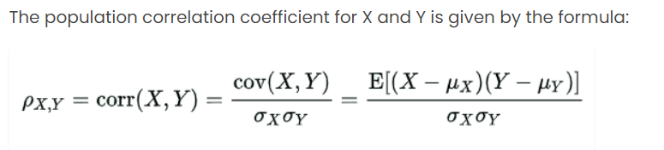

Where,

ρXY = Population correlation coefficient between X and Y

μX = Mean of the variable X

μY = Mean of the variable Y

σX = Standard deviation of X

σY = Standard deviation of Y

E = Expected value operator

Cov = Covariance

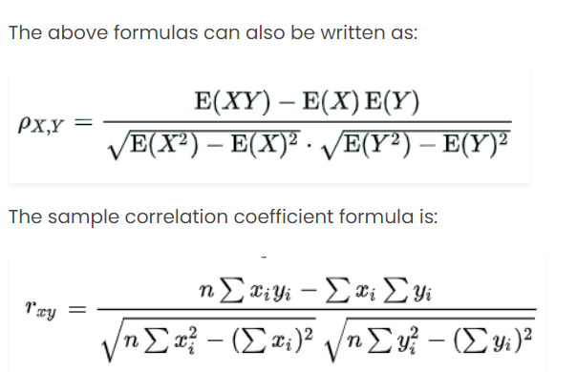

The correlation coefficient measures the linear relationship between variables but does not imply causation. It only captures the degree to which the variables tend to move together or in opposite directions. Other types of relationships, such as non-linear or curvilinear, may not be captured by the correlation coefficient.

The magnitude of the correlation coefficient indicates the strength of the relationship. A value closer to -1 or +1 indicates a stronger correlation, while a value closer to 0 indicates a weaker correlation. Additionally, the sign of the coefficient (+/-) indicates the direction of the relationship: positive if the variables move together, and negative if they move in opposite directions.

The correlation coefficient is a valuable tool in analyzing and understanding relationships between variables, helping to assess the degree of association and inform further analysis or decision-making. However, it is important to interpret it within the context of the specific data and consider other factors when drawing conclusions.

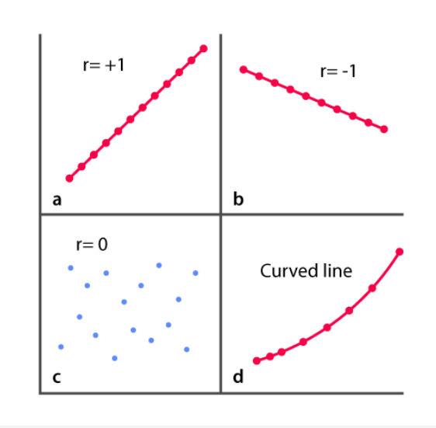

The degree of association is measured by “r” after its originator and a measure of linear association.

ASSUMPTIONS OF LINEAR REGRESSION

Linear regression relies on several key assumptions to ensure the validity and reliability of the model's results. Here are the main assumptions of linear regression:

**Independence:** The observations in the dataset are assumed to be independent of each other. This assumption implies that the values of the dependent variable for one observation are not influenced by or related to the values of the dependent variable for other observations.

**Hidden or Missing Variables**

The second assumption of the linear regression model is that you have used all relevant explanatory variables in your model. If you do not do this, you end up with a wrong model, as the model will try to assign coefficients to the variables that do exist in your data set. This is often referred to as misspecification of a model.

If adding a variable to the model would make a whole lot of difference, it means that the model is incorrect and useless without it. The only thing you can do in this case is to get back to your data collection to find the necessary data.

**Linearity:** The relationship between the dependent variable and the independent variable(s) is assumed to be linear. The model assumes that the relationship can be adequately captured by a straight line or plane.

You can check for linear relationships easily by making a scatter plot for each independent variable with the dependent variable.

**Normality:** The errors (residuals) follow a normal distribution. This assumption implies that the residuals should be normally distributed with a mean of zero. Normality assumption is important for hypothesis testing, confidence intervals, and other statistical inferences.

**No multicollinearity:** In multiple linear regression, the independent variables should not be highly correlated with each other. High multicollinearity can lead to difficulties in interpreting the individual effects of the independent variables and can impact the stability of the regression estimates.

**Homoscedasticity:** The variance of the errors (residuals) is constant across all levels of the independent variables. This assumption suggests that the spread of the residuals should be consistent throughout the range of the independent variable(s).

**All independent variables are uncorrelated with the error term**

The seventh diagnostic check of your linear regression model serves to check whether there is correlation between any of the independent variables and the error term. If this happens, it is likely that you have a case of a misspecified model. You may have forgotten an important explanatory variable.

**No endogeneity:** The model assumes that there is no reverse causality or feedback loop between the dependent variable and the independent variables. In other words, the independent variables are not affected by the dependent variable.

**No influential outliers:** Outliers are extreme observations that can unduly influence the regression results. Linear regression assumes that there are no influential outliers that significantly affect the estimated coefficients and model fit.

TESTING FOR SIGNIFICANCE

In linear regression, testing for significance helps determine whether the relationship between the independent variable(s) and the dependent variable is statistically significant or if it could have occurred by chance. Significance testing involves assessing the null hypothesis that there is no relationship between the variables against the alternative hypothesis that there is a significant relationship.

The most common test used to assess the significance of the relationship in linear regression is the t-test. The t-test is conducted on the estimated coefficients (slopes) of the independent variables to determine if they are significantly different from zero.

The steps for testing the significance of a coefficient in linear regression are as follows:

**Set up the hypotheses:**

Null hypothesis (H0): The coefficient is equal to zero (no relationship).

Alternative hypothesis (Ha): The coefficient is not equal to zero (significant relationship).

**Calculate the t-statistic for the coefficient:**

The t-statistic is calculated by dividing the estimated coefficient by its standard error. The formula is:

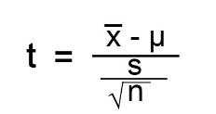

Where,

x̄ = Observed Mean of the Sample

μ = Theoretical Mean of the Population

s = Standard Deviation of the Sample

n = Sample Size

**Determine the critical value:**

The critical value is determined based on the desired level of significance (alpha) and the degrees of freedom. The degrees of freedom are typically n - k - 1, where n is the sample size and k is the number of independent variables.

**Compare the calculated t-value with the critical value:**

If the calculated t-value is greater than the critical value (or falls in the rejection region), the null hypothesis is rejected, indicating a significant relationship. Otherwise, if the calculated t-value is smaller than the critical value (or falls in the non-rejection region), the null hypothesis cannot be rejected, suggesting no significant relationship.

**Determine the p-value:**

The p-value is the probability of observing a t-value as extreme as the calculated t-value under the null hypothesis. If the p-value is less than the chosen significance level (alpha), typically 0.05, the null hypothesis is rejected in favor of the alternative hypothesis.

By testing the significance of each coefficient, you can determine which independent variables have a statistically significant relationship with the dependent variable. This information helps in understanding which variables are important in explaining the variation in the dependent variable.

The estimated regression equation obtained from linear regression analysis can be used for both estimation and prediction purposes

**Estimation:**

Estimation involves using the regression equation to estimate the expected value of the dependent variable (y) for a given set of independent variable values (x). By plugging in the values of the independent variables into the equation, you can estimate the corresponding value of the dependent variable.

For example, in a simple linear regression equation ŷ = b0 + b1 * x, where ŷ is the estimated value of the dependent variable, b0 is the y-intercept, and b1 is the slope coefficient, you can estimate ŷ by substituting the value of x into the equation.

Estimation is useful for determining the average or expected value of the dependent variable based on specific values of the independent variable(s) within the observed data range.

**Prediction:**

Prediction involves using the regression equation to predict the value of the dependent variable for new or unseen values of the independent variable(s). This allows you to make forecasts or projections based on the relationship established by the regression model.

To make a prediction, you plug in the values of the independent variable(s) into the regression equation, and the equation provides an estimated value of the dependent variable.

It's important to note that when making predictions, the reliability and accuracy of the predictions depend on the quality and representativeness of the data used to estimate the regression equation. Predictions outside the observed data range may carry more uncertainty and should be made with caution.

Both estimation and prediction using the estimated regression equation can be valuable for understanding relationships between variables, making forecasts, and informing decision-making. However, it's crucial to interpret the results within the context of the specific data and consider the assumptions and limitations of the regression model.

Validating the assumptions of a linear regression model is essential to ensure the reliability and accuracy of the model's results. Here are some common techniques for validating the assumptions of a linear regression model:

**Residual Analysis:**

Residuals are the differences between the observed values of the dependent variable and the predicted values from the regression model. Analyzing the residuals helps assess several assumptions, including linearity, independence, homoscedasticity, and normality.

Linearity: Plot the residuals against the predicted values. If the plot exhibits a random scatter pattern with no discernible trend, it suggests that the linearity assumption is met.

Independence: Examine autocorrelation in the residuals by plotting the residuals against the order of observation or the time variable. If no pattern or correlation is observed, the assumption of independence is likely valid.

Homoscedasticity: Plot the residuals against the predicted values or the independent variables. If the spread of residuals is consistent across the range of predicted values or independent variables, the assumption of homoscedasticity is met.

Normality: Plot a histogram or a normal probability plot of the residuals. If the distribution appears approximately symmetric and bell-shaped, it indicates that the normality assumption is reasonably satisfied.

**Cook's Distance:**

Cook's distance is a measure that helps identify influential observations in the regression analysis. It quantifies how much the estimated coefficients change when a particular observation is removed from the analysis. Large values of Cook's distance indicate influential observations that may significantly affect the regression results.

**Multicollinearity:**

Assess the presence of multicollinearity by examining the correlation matrix or variance inflation factor (VIF) for the independent variables. High correlations or VIF values suggest the presence of multicollinearity, which can affect the stability and interpretability of the regression coefficients.

**Outliers and Leverage:**

Identify outliers by examining the standardized residuals. Outliers are observations with unusually large residuals that may have a significant impact on the regression results. Additionally, leverage measures how extreme or unusual an observation is in terms of the independent variable values. High-leverage observations may have a considerable influence on the regression coefficients.

**Cross-Validation:**

Cross-validation techniques, such as k-fold cross-validation or hold-out validation, can be used to assess the predictive performance of the regression model. These techniques involve splitting the data into training and testing sets and evaluating how well the model generalizes to unseen data.

**Robust Regression:**

If the assumptions of linear regression are severely violated, robust regression techniques can be considered. Robust regression methods, such as robust standard errors or robust regression algorithms (e.g., Huber, M-estimators), are less sensitive to violations of assumptions and can provide more reliable estimates in the presence of outliers or heteroscedasticity.

**Influential Observations:**

Influential observations are data points that have a significant effect on the regression analysis. They can have a substantial impact on the estimated coefficients, standard errors, and predictions. Influential observations can be outliers but are not limited to being outliers.

There are several measures to assess the influence of observations:

Leverage: Leverage measures how extreme or unusual an observation is in terms of the independent variable values. Observations with high leverage can have a disproportionate influence on the regression coefficients.

Cook's Distance: Cook's distance measures the influence of an observation on the estimated coefficients. Observations with large Cook's distances are considered influential.

Influential observations should be carefully examined to understand their effect on the regression results. If influential observations significantly affect the analysis, it may be necessary to reconsider the model, evaluate the data quality, or explore alternative regression techniques.

OUTLIER ANALYSIS

Outlier analysis in simple linear regression involves identifying and assessing the impact of outliers on the regression model's results. Here's an outline of the steps involved in outlier analysis for simple linear regression:

**Scatter Plot:**

Begin by creating a scatter plot of the data, with the independent variable on the x-axis and the dependent variable on the y-axis. Visualizing the data helps identify any potential outliers that deviate significantly from the overall pattern.

**Residual Analysis:**

Calculate the residuals, which are the differences between the observed values of the dependent variable and the predicted values from the regression model. Plot the residuals against the independent variable to identify any points with unusually large residuals. These points may indicate potential outliers.

**Outlier Detection Techniques:**

There are various techniques to identify outliers in simple linear regression, including:

Z-Score or Standardized Residuals: Compute the z-scores of the residuals by subtracting the mean and dividing by the standard deviation. Outliers can be defined as observations with z-scores above a certain threshold (e.g., ±2 or ±3).

Studentized Residuals: Calculate the studentized residuals, which are the residuals divided by their estimated standard deviation. Outliers can be identified as observations with absolute studentized residuals exceeding a critical value (e.g., ±2 or ±3).

Cook's Distance: Compute Cook's distance for each observation, which measures the influence of an observation on the estimated regression coefficients. Observations with large Cook's distances are considered potential outliers.

**Interpretation and Validation:**

Once potential outliers are identified, it's important to assess their impact on the regression model. Consider the following factors:

Influence: Assess the leverage of the potential outliers to determine their influence on the estimated coefficients. High-leverage points may have a significant impact on the regression results.

Model Fit: Evaluate the regression model's goodness-of-fit measures, such as R-squared or adjusted R-squared, with and without the potential outliers. Comparing these measures helps assess the impact of outliers on the model's overall fit.

**Decision and Treatment:**

Based on the analysis and interpretation, make a decision regarding the treatment of the outliers. Options include:

Exclude Outliers: If outliers are identified as data errors or extreme observations that do not align with the overall data pattern, you may choose to exclude them from the analysis. However, this decision should be made carefully, considering the potential impact on the validity and representativeness of the data.

Transformation: If the outliers are genuine data points but have a disproportionate influence, you can consider transforming the data (e.g., using a logarithmic transformation) to reduce their impact.

Robust Regression: Alternatively, you may opt to use robust regression techniques that are less sensitive to outliers, such as M-estimators or robust standard errors

MULTIPLE REGRESSION

Multiple linear regression (MLR), also known simply as multiple regression, is a statistical technique that uses several explanatory variables to predict the outcome of a response variable. The goal of multiple linear regression is to model the linear relationship between the explanatory (independent) variables and response (dependent) variables. In essence, multiple regression is the extension of ordinary least-squares (OLS) regression because it involves more than one explanatory variable.

It extends the concept of simple linear regression, which only considers one independent variable, to incorporate multiple predictors.

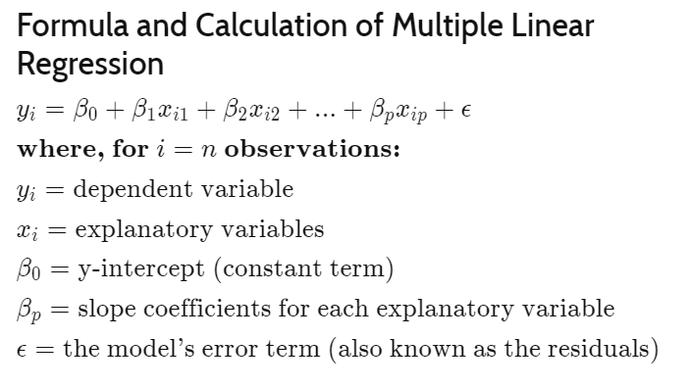

The multiple regression model is based on the following assumptions:

1. There is a linear relationship between the dependent variables and the independent variables
2. The independent variables are not too highly correlated with each other
3. yi observations are selected independently and randomly from the population
4. Residuals should be normally distributed with a mean of 0 and variance σ

Once each of the independent factors has been determined to predict the dependent variable, the information on the multiple variables can be used to create an accurate prediction on the level of effect they have on the outcome variable. The model creates a relationship in the form of a straight line (linear) that best approximates all the individual data points.

Example:

Suppose we want to examine the factors that influence a student's academic performance, measured by their final exam score. We collect data on three independent variables: hours of study per week (x1), number of extracurricular activities (x2), and previous GPA (x3). The dependent variable is the final exam score (y).

We can use multiple regression to find out the dependency.

LEAST SQUARE METHOD IN MULTIPLE REGRESSION

The least squares method is a common approach used to estimate the regression coefficients in multiple regression. It aims to minimize the sum of the squared differences between the observed values of the dependent variable and the predicted values from the regression equation.

In multiple regression, the least squares method involves the following steps:

**Model Specification:** Determine the form of the multiple regression equation by selecting the independent variables to include in the model based on theoretical considerations or domain knowledge.

**Data Collection:** Gather data on the dependent variable and the independent variables for a sample of observations.

**Estimation of Coefficients:** Estimate the regression coefficients (b0, b1, b2, ..., bn) that best fit the data by minimizing the sum of squared residuals.

* The sum of squared residuals is calculated as the sum of the squared differences between the observed values of the dependent variable (y) and the predicted values (ŷ) from the regression equation.
* The regression coefficients are estimated using numerical optimization techniques that minimize the sum of squared residuals. The most common method is ordinary least squares (OLS), which provides unbiased estimates of the coefficients.

**Model Assessment:** Evaluate the overall fit of the regression model and assess the statistical significance of the coefficients.

* Goodness-of-fit measures such as R-squared and adjusted R-squared quantify the proportion of variance in the dependent variable explained by the independent variables.
* Hypothesis tests, such as t-tests or F-tests, can be performed to determine the significance of individual coefficients or groups of coefficients.

**Interpretation:** Interpret the estimated regression coefficients to understand the relationship between the independent variables and the dependent variable. A positive coefficient indicates a positive association, while a negative coefficient indicates a negative association.

**Prediction and Inference:** Use the estimated regression equation to predict the values of the dependent variable for given values of the independent variables. Additionally, conduct inference by testing hypotheses, constructing confidence intervals, or making predictions within certain bounds.

MULTIPLE COEFFICIENT OF DETERMINATION

The multiple coefficient of determination, often denoted as R-squared (R^2), is a measure of the proportion of variance in the dependent variable that can be explained by the independent variables in a multiple regression model. It indicates how well the independent variables collectively predict the variation in the dependent variable.

In multiple regression, R-squared is calculated as the squared correlation between the observed values of the dependent variable and the predicted values from the regression model. It ranges from 0 to 1, with higher values indicating a better fit of the model to the data. Here's the formula for R-squared:

R^2 = 1 - (SSR / SST)

Where:

SSR (Sum of Squares Residuals) is the sum of the squared differences between the observed values of the dependent variable and the predicted values from the regression model.

SST (Sum of Squares Total) is the sum of the squared differences between the observed values of the dependent variable and the mean of the dependent variable.

The interpretation of R-squared is as follows:

R-squared of 0 indicates that none of the variation in the dependent variable is explained by the independent variables.

R-squared of 1 indicates that all the variation in the dependent variable is explained by the independent variables.

MODEL ASSUMPTIONS FOR MULTIPLE REGRESSION

Multiple regression relies on several assumptions to ensure the validity of the regression analysis and the interpretation of the results. Here are the key assumptions for multiple regression:

**Linearity:** The relationship between the dependent variable and each independent variable is assumed to be linear. This means that the change in the dependent variable is proportional to the change in each independent variable, holding other variables constant.

**Independence:** The observations in the dataset should be independent of each other. This assumption implies that there is no systematic relationship or correlation between the residuals or errors of the regression model.

**Homoscedasticity:** The variance of the residuals should be constant across all levels of the independent variables. In other words, the spread or dispersion of the residuals should not systematically change as the values of the independent variables change.

**Normality of Residuals:** The residuals should follow a normal distribution, indicating that the errors have a mean of zero and constant variance. This assumption is important for conducting hypothesis tests, constructing confidence intervals, and making valid statistical inferences.

**No Multicollinearity**: The independent variables should not be highly correlated with each other. Multicollinearity occurs when there are strong linear relationships between two or more independent variables, making it difficult to separate their individual effects on the dependent variable. Multicollinearity can lead to unstable or unreliable estimates of the regression coefficients.

**No Endogeneity:** There should be no endogeneity, which refers to a situation where the independent variables are correlated with the error term. Endogeneity can arise due to omitted variables, measurement errors, or simultaneity in the relationships among the variables.

TESTING FOR SIGNIFICANCE FOR MULTIPLE REGRESSION

Testing for significance in multiple regression involves assessing the statistical significance of the regression coefficients to determine if they are significantly different from zero. This helps determine if the independent variables have a meaningful and significant impact on the dependent variable.

The most common approach for testing the significance of the regression coefficients in multiple regression is to use hypothesis testing. The null hypothesis (H0) states that the regression coefficient is equal to zero, indicating that the corresponding independent variable has no effect on the dependent variable. The alternative hypothesis (H1) states that the regression coefficient is not equal to zero, indicating a significant effect.

To test the significance of an individual coefficient, a t-test is typically used. The t-test assesses whether the estimated coefficient is significantly different from zero, taking into account the standard error of the coefficient. The t-statistic is calculated by dividing the estimated coefficient by its standard error. The resulting t-value is compared to a critical value from the t-distribution, with the degrees of freedom determined by the sample size and the number of independent variables.

If the absolute value of the t-value exceeds the critical value (typically based on a chosen significance level, such as 0.05 or 0.01), then the null hypothesis is rejected, and it can be concluded that the independent variable has a significant effect on the dependent variable.

Additionally, you can use an F-test to test the joint significance of a group of independent variables. The F-test compares the overall fit of the regression model with all the independent variables to a restricted model without those variables. It calculates the ratio of the explained variation (sum of squares regression) to the unexplained variation (sum of squares residuals) and follows an F-distribution. If the F-statistic exceeds the critical value based on the chosen significance level, it indicates that at least one of the independent variables has a significant effect on the dependent variable.

CATEGORICAL INDEPENDENT VARIABLES

When dealing with categorical independent variables in multiple regression, there are a few considerations to keep in mind. Categorical variables are variables that represent groups or categories rather than numerical values. These variables can be nominal, where there is no inherent order, or ordinal, where there is a specific order or ranking.

To include categorical variables in multiple regression, they need to be converted into a set of binary (dummy) variables. This process is called "dummy coding" or "indicator coding" and involves creating separate variables that represent each category of the categorical variable.

For example, let's consider a categorical variable "Color" with three categories: Red, Green, and Blue. To include this variable in a multiple regression model, we would create two dummy variables, typically using one category as the reference or baseline category. The resulting dummy variables would be:

Dummy variable 1 (Red): 1 if the observation is Red, 0 otherwise.

Dummy variable 2 (Green): 1 if the observation is Green, 0 otherwise.

The baseline category, in this case, could be Blue, so if both dummy variables are 0, it implies that the observation is Blue.

Once the categorical variable is dummy-coded, these binary variables can be treated as regular numerical independent variables in the multiple regression analysis. The regression model would include the dummy variables along with other continuous independent variables.

It's important to note that the interpretation of the regression coefficients for categorical variables differs from that of continuous variables. The coefficient for each dummy variable represents the difference in the dependent variable between the respective category and the baseline category.

For example, if the estimated coefficient for the dummy variable representing "Red" is 5, it means that, on average, the dependent variable is 5 units higher for observations in the Red category compared to the baseline category (e.g., Blue), controlling for other independent variables in the model.